Windows 10 Wireless Printing
Use this tool to get instructions on how to connect to Library printers over the wireless network on your Windows 10 device.

- You must be logged into the campus wireless in order to connect to and use these campus printers.
Step 1
Open File Explorer
(Press the Windows key. Type FILE. Select File Explorer.)
- Step 2
In the address bar, type \\goprint.doit.wisc.edu
and hit Enter.
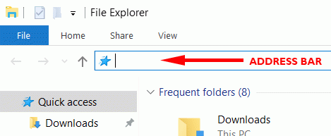
Step 3
Use your NetID and NetID password if asked using this format:
Username:
AD\NETID
Password:
YOUR NETID PASSWORD
(A list of printers will appear.)
- Step 4
Right click on
LAW_B&W
and click Connect...

- Step 5
The printer should begin installing. This process can take a few minutes with little to no feedback on your screen.
You may be prompted to install a printer driver. If so, click Install Driver.
The printer is now installed. Make sure to select it when printing.
Your print jobs will appear on the GoPrint queue under your NetID.

